Kader  Academy  Book Hunt Challenge!  4th March 2021 |  | Hello grown-ups!  On the 4th March 2021,  World Book Day, we are having a whole school book hunt.  Here are 12 cards to hide around your house/garden for your child/children to find!  There is a secret message for children to decode – a help  card is included to support.  (Siblings may of course work together to help one another.  Littles may need some help from a grown up!) |  | Hello children of Kader!  f  Your grown-ups have hidden 12 book cards…it is  your quest to find them all!  There is also a secret message you can work out if you find every card! ‘These books gave Matilda a hopeful and comforting message:  _ _ _ _ _ _ _ _ _ _ _ _ _ _ ’
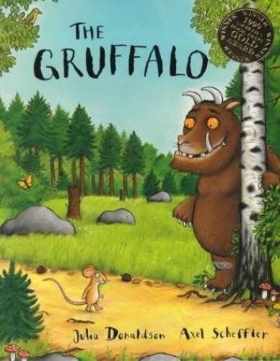 |  | 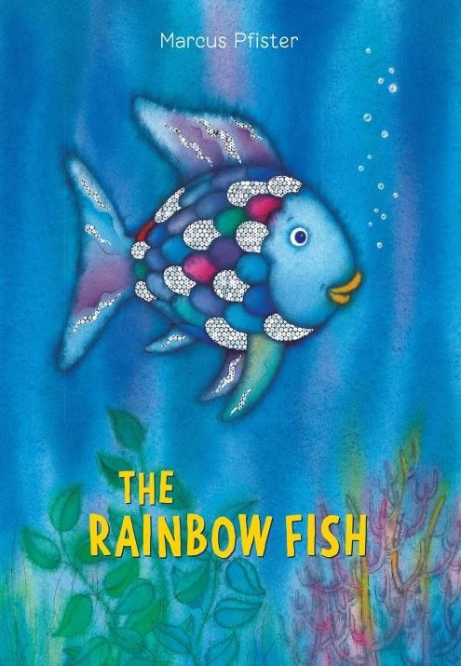 |  | 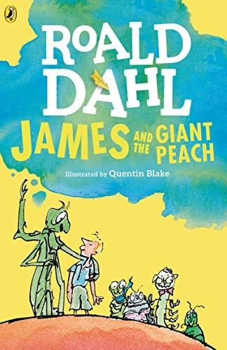 |  | 